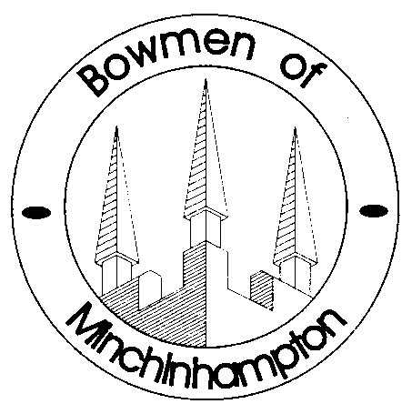
The Paddocks, Eastcombe, Gloucestershire GL6 7DR
01452 770143
pcmeastcombe@btinternet.com

ADDITIONAL INDOOR SHOOTING AT MAIDENHILL SPORTS CENTRE
March/ April 2015
REVISED

Saturday 28th March | 10.00am to 12.00 midday
Monday 30th March | 6.00pm to 8.00pm
Tuesday 7th April | 7.00pm to 9.00pm
Friday 10th April | 7.30pm to 9.30pm
Tuesday 14th April | 7.00pm to 9.00pm
Friday 17th April | 7.30pm to 9.30pm
Tuesday 21st April | 7.00pm to 9.00pm
Friday 24th April | 7.30pm to 9.30pm
Tuesday 28th April | 7.00pm to 9.00pm

Peter Munday
Secretary
Bowmen of Minchinhampton

